SOP & LINK ZOOM PESERTA SIDANG FIKOMM
UNIVERSITAS MERCU BUANA YOGYAKARTA

LANGKAH MENGGUNAKAN LINK ZOOM FAKULTAS UMBY:
- Buka aplikasi zoom meeting di laptop yang disediakan laboratorium FIKOMM :
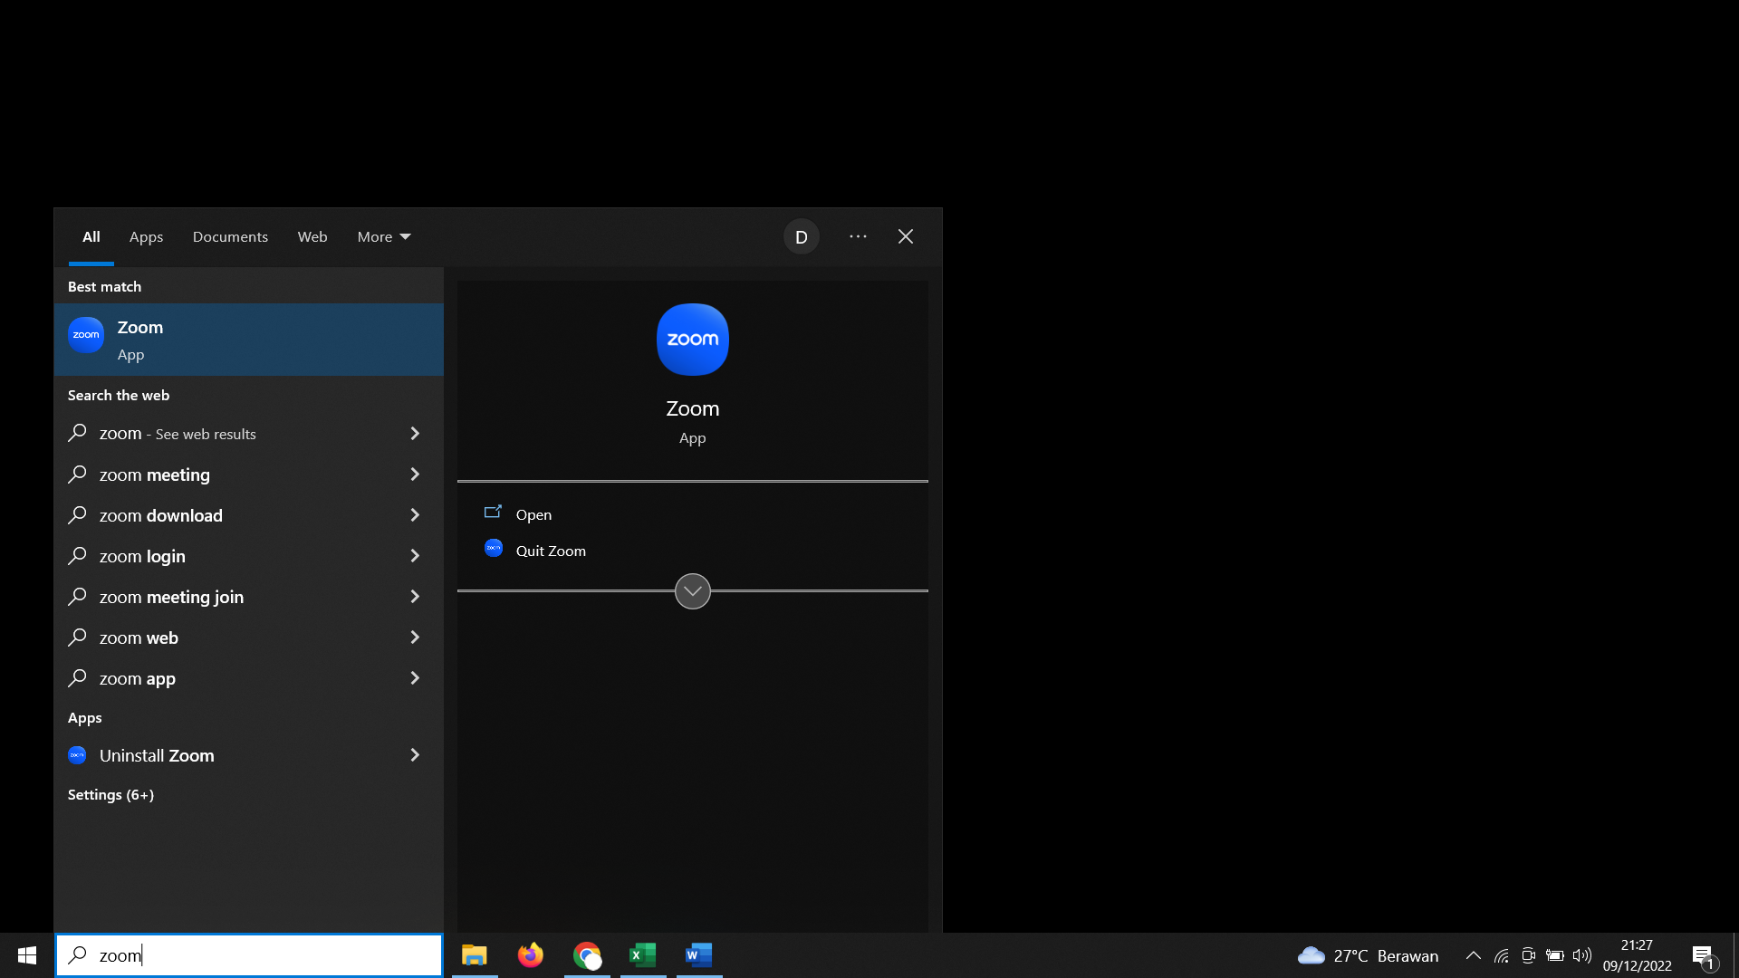
- Silahkan cari Nama anda dan Klik ”Start Meeting”
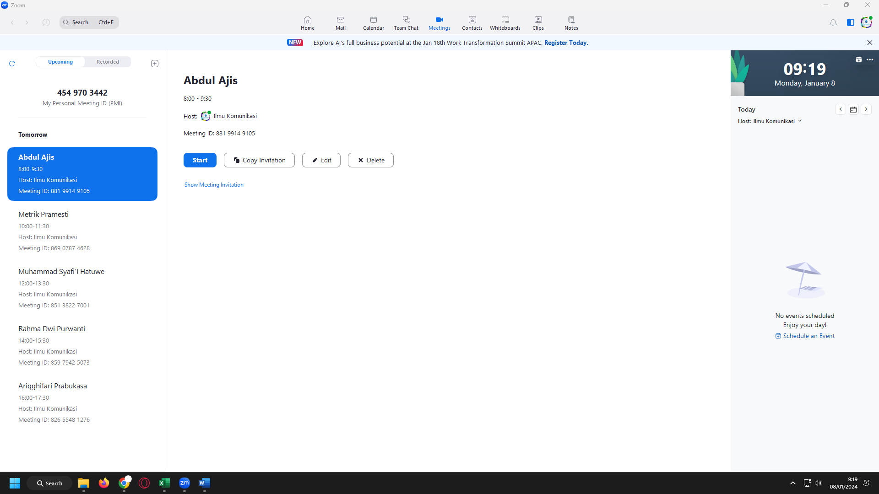

- Link Sidang untuk dikirimkan ke dosen pembimbing anda di bawah ini (link terlampir)
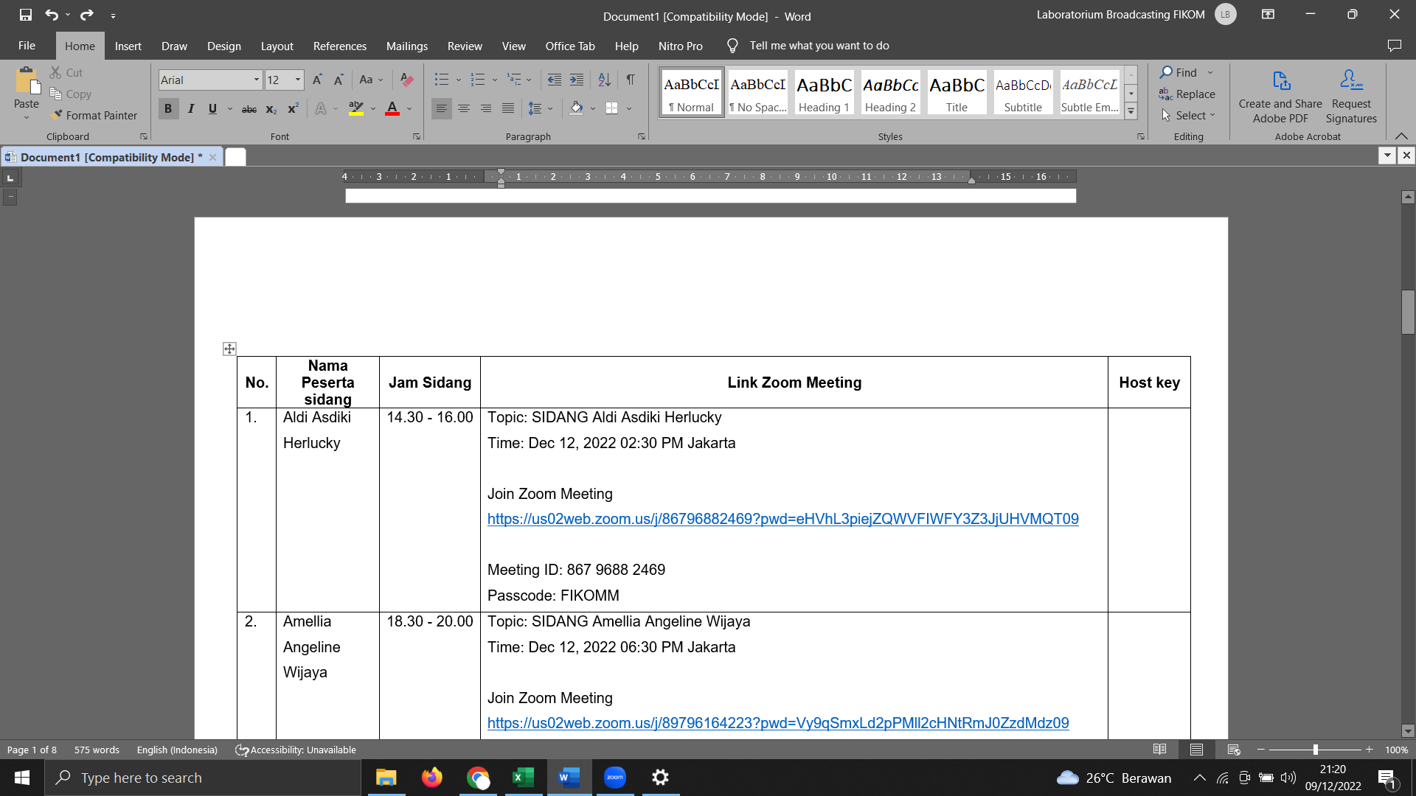

- Materi di upload di link :
https://drive.google.com/drive/folders/1q6L1y5oV6fh7vsMo9sciWts-Lqi8qzpx?usp=sharing

(akses bisa CTRL+Klik link di atas)

LINK ZOOM SIDANG PERIODE JULI (Rabu, 10 Juli 2024)
No. | Nama Peserta sidang | Jam Sidang | Link Zoom Meeting | Host key
 | Noni Amela Nainggolan | 08.00 - 09.30 | Topic: Noni Amela Nainggolan  Time: Jul 10, 2024 08:00 Jakarta  Join Zoom Meeting  https://us02web.zoom.us/j/85153566354?pwd=PPghc5QInIil2LXM3OcspbfZut6ijE.1  Meeting ID: 851 5356 6354  Passcode: FIKOMM | Host Key:  012023
 | Adelia Rahmi Pratiwi | 10.00 - 11.30 | Topic: Adelia Rahmi Pratiwi  Time: Jul 10, 2024 10:00 Jakarta  Join Zoom Meeting  https://us02web.zoom.us/j/82962709292?pwd=2KhOebtC2OX9IzaMGtkiGa73bnG39h.1  Meeting ID: 829 6270 9292  Passcode: FIKOMM | Host Key:  012023
 | Dionysius Catur Formantya | 12.00 - 13.30 | Topic: Dionysius Catur Formantya  Time: Jul 10, 2024 12:00 Jakarta  Join Zoom Meeting  https://us02web.zoom.us/j/89175891012?pwd=aXq82Ou6jzZ12LwZQqYYspHCh4sy9j.1  Meeting ID: 891 7589 1012  Passcode: FIKOMM | Host Key:  012023
 | Benedikta Efriany | 14.00 - 15.30 | Topic: Benedikta Efriany  Time: Jul 10, 2024 14:00 Jakarta  Join Zoom Meeting  https://us02web.zoom.us/j/86452800448?pwd=I9um6vfi1ncQFuRDbFbVvphuHbSFl6.1  Meeting ID: 864 5280 0448  Passcode: FIKOMM | Host Key:  012023
 | Aulya Yassyifa | 16.00 - 17.30 | Topic: Aulya Yassyifa  Time: Jul 10, 2024 16:00 Jakarta  Join Zoom Meeting  https://us02web.zoom.us/j/85172237736?pwd=CMBp5bpuGHXqOcetcEP0DZO0E5wrXN.1  Meeting ID: 851 7223 7736  Passcode: FIKOMM | Host Key:  012023
 | Angela Maria Bria Resi | 18.30 - 20.00 | Topic: Angela Maria Bria Resi  Time: Jul 10, 2024 18:30 Jakarta  Join Zoom Meeting  https://us02web.zoom.us/j/86074474748?pwd=QXZFsv6llzuLZKpns6NBFdUZa3U5mQ.1  Meeting ID: 860 7447 4748  Passcode: FIKOMM | Host Key:  012023

LINK ZOOM SIDANG PERIODE JULI (Kamis, 11 Juli 2024)
No. | Nama Peserta sidang | Jam Sidang | Link Zoom Meeting | Host key
 | Loura Petronela Lingkan Posumah | 08.00 - 09.30 | Topic: Loura Petronela Lingkan Posumah  Time: Jul 11, 2024 08:00 Jakarta  Join Zoom Meeting  https://us02web.zoom.us/j/89611092276?pwd=pAgzPc0wRrdoExbaaqYWLLRXS3Y9Fq.1  Meeting ID: 896 1109 2276  Passcode: FIKOMM | Host Key:  012023
 | Annisa Ghina Wasiilah | 10.00 - 11.30 | Topic: Annisa Ghina Wasiilah  Time: Jul 11, 2024 10:00 Jakarta  Join Zoom Meeting  https://us02web.zoom.us/j/82945067318?pwd=l4rRHVuxZjXmk3biJvBVRK3nh797hl.1  Meeting ID: 829 4506 7318  Passcode: FIKOMM | Host Key:  012023
 | Sancaya Ranu Pratama | 17071016 | Topic: Sancaya Ranu Pratama  Time: Jul 11, 2024 12:00 Jakarta  Join Zoom Meeting  https://us02web.zoom.us/j/84010009095?pwd=2jdy31OrqD9bRoFKva4zlQktmNo2QI.1  Meeting ID: 840 1000 9095  Passcode: FIKOMM | Host Key:  012023
 | Febriansyah | 14.00 - 15.30 | Topic: Febriansyah  Time: Jul 11, 2024 14:00 Jakarta  Join Zoom Meeting  https://us02web.zoom.us/j/88583666212?pwd=8CfyEiW3D2FE9c1ZxYv3rCwPdBaCpz.1  Meeting ID: 885 8366 6212  Passcode: FIKOMM | Host Key:  012023
 | Desi Natalia Nigita Br Brahmana | 16.00 - 17.30 | Topic: Desi Natalia Nigita Br Brahmana  Time: Jul 11, 2024 16:00 Jakarta  Join Zoom Meeting  https://us02web.zoom.us/j/89753916535?pwd=lNOe2vvydWA6aVNaUpyQMCNgoQv1Py.1  Meeting ID: 897 5391 6535  Passcode: FIKOMM | Host Key:  012023
 | Frisa Afra Fadhilah | 18.30 - 20.00 | Topic: Frisa Afra Fadhilah  Time: Jul 11, 2024 18:30 Jakarta  Join Zoom Meeting  https://us02web.zoom.us/j/85352719228?pwd=3L5AWgSNvgEkpu5gMJ6k3M8X9j4z7e.1  Meeting ID: 853 5271 9228  Passcode: FIKOMM | Host Key:  012023

LINK ZOOM SIDANG PERIODE JULI (Jumat, 12 Juli 2024)
No. | Nama Peserta sidang | Jam Sidang | Link Zoom Meeting | Host key
 | Nahda Shafirah Rahayu | 08.00 - 09.30 | Topic: Nahda Shafirah Rahayu  Time: Jul 12, 2024 08:00 Jakarta  Join Zoom Meeting  https://us02web.zoom.us/j/88046856513?pwd=iw5bEsIzbprnjYerrTqukTmgbVHnwD.1  Meeting ID: 880 4685 6513  Passcode: FIKOMM | Host Key:  012023
 | Afrel Elda Magdalena | 10.00 - 11.30 | Topic: Afrel Elda Magdalena  Time: Jul 12, 2024 10:00 Jakarta  Join Zoom Meeting  https://us02web.zoom.us/j/84226001295?pwd=WdO18IuHY7iyNWaWfaMv88IEmTGxV9.1  Meeting ID: 842 2600 1295  Passcode: FIKOMM | Host Key:  012023
 | Nicolas Fandy Ardiyanto | 14.00 - 15.30 | Topic: Nicolas Fandy Ardiyanto  Time: Jul 12, 2024 14:00 Jakarta  Join Zoom Meeting  https://us02web.zoom.us/j/87003582875?pwd=WwMrneVf4NypOuKXbmfbdAcnSUPlqS.1  Meeting ID: 870 0358 2875  Passcode: FIKOMM | Host Key:  012023
 | Michael Panji Laksana Nugroho | 16.00 - 17.30 | Topic: Michael Panji Laksana Nugroho  Time: Jul 12, 2024 16:00 Jakarta  Join Zoom Meeting  https://us02web.zoom.us/j/86997288748?pwd=iC5AuhDpYvQfD0KnJhAubtlN96GDrZ.1  Meeting ID: 869 9728 8748  Passcode: FIKOMM | Host Key:  012023
 | Anang Syahrul Mubarok | 18.30 - 20.00 | Topic: Anang Syahrul Mubarok  Time: Jul 12, 2024 18:30 Jakarta  Join Zoom Meeting  https://us02web.zoom.us/j/87389762506?pwd=MgsaytkQl94LqbU15iNyN8wElWRUlF.1  Meeting ID: 873 8976 2506  Passcode: FIKOMM | Host Key:  012023

LINK ZOOM SIDANG PERIODE JULI (Senin, 15 Juli 2024)
No. | Nama Peserta sidang | Jam Sidang | Link Zoom Meeting | Host key
 | Amelia Septiani Puspitasari | 08.00 - 09.30 | Topic: Amelia Septiani Puspitasari  Time: Jul 15, 2024 08:00 Jakarta  Join Zoom Meeting  https://us02web.zoom.us/j/82355095075?pwd=EPjyoZa0FcsNWb8bbe2bcqMPm9xYxv.1  Meeting ID: 823 5509 5075  Passcode: FIKOMM | Host Key:  012023
 | Grizelda Audrey Faschalia | 08.00 - 09.30 | Topic: Grizelda Audrey Faschalia  Time: Jul 15, 2024 08:00 Jakarta  Join Zoom Meeting  https://telkomsel.zoom.us/j/98420975099?pwd=nk8Yxh9blY4AuLzx2KM5iIxdoHAo8e.1  Meeting ID: 984 2097 5099  Passcode: FIKOMM | Host Key:  012023
 | Abraham Satrio Wibowo | 10.00 - 11.30 | Topic: Abraham Satrio Wibowo  Time: Jul 15, 2024 10:00 Jakarta  Join Zoom Meeting  https://us02web.zoom.us/j/85890091265?pwd=nwVq1qQoxu4Kb7wYBdNPtn33lAZJwB.1  Meeting ID: 858 9009 1265  Passcode: FIKOMM | Host Key:  012023
 | Rosalia Gunawan | 10.00 - 11.30 | Topic: Rosalia Gunawan  Time: Jul 15, 2024 10:00 Jakarta  Join Zoom Meeting  https://telkomsel.zoom.us/j/93506797345?pwd=2cBag2lHoGHQTm4b8avP8I6jzAwbs8.1  Meeting ID: 935 0679 7345  Passcode: FIKOMM | Host Key:  012023
 | Widagdo Dwi Nugroho | 16.00 - 17.30 | Topic: Widagdo Dwi Nugroho  Time: Jul 15, 2024 16:00 Jakarta  Join Zoom Meeting  https://us02web.zoom.us/j/82476398034?pwd=19JHUhNU3X2pupmIX4lgTQjtSwjlBW.1  Meeting ID: 824 7639 8034  Passcode: FIKOMM | Host Key:  012023
 | Weningtyas Tris Handayani | 16.00 - 17.30 | Topic: Weningtyas Tris Handayani  Time: Jul 15, 2024 16:00 Jakarta  Join Zoom Meeting  https://telkomsel.zoom.us/j/96449049178?pwd=9refh73XanjIvnpJ61vVfugQacb649.1  Meeting ID: 964 4904 9178  Passcode: FIKOMM | Host Key:  012023
 | Robin Abdurrahman | 18.30 - 20.00 | Topic: Robin Abdurrahman  Time: Jul 15, 2024 18:30 Jakarta  Join Zoom Meeting  https://us02web.zoom.us/j/89207114525?pwd=YEPBTaOmILxVBadzDMSdIrQQDDlInT.1  Meeting ID: 892 0711 4525  Passcode: FIKOMM | Host Key:  012023
 | Gladys Andri Syakira | 18.30 - 20.00 | Topic: Gladys Andri Syakira  Time: Jul 15, 2024 18:30 Jakarta  Join Zoom Meeting  https://telkomsel.zoom.us/j/98369188515?pwd=AF8pGs8T11c9U74rvK8cay9xaZqbsi.1  Meeting ID: 983 6918 8515  Passcode: FIKOMM | Host Key:  012023

LINK ZOOM SIDANG PERIODE JULI (Selasa, 16 Juli 2024)
No. | Nama Peserta sidang | Jam Sidang | Link Zoom Meeting | Host key
 | Yunita Sekar Anjani | 08.00 - 09.30 | Topic: Yunita Sekar Anjani  Time: Jul 16, 2024 08:00 Jakarta  Join Zoom Meeting  https://us02web.zoom.us/j/85229044722?pwd=mwbFvyFBAbfdi1PGpQxX8Xbnwuxtey.1  Meeting ID: 852 2904 4722  Passcode: FIKOMM | Host Key:  012023
 | Adin Kusno Putri | 08.00 - 09.30 | Topic: Adin Kusno Putri  Time: Jul 16, 2024 08:00 Jakarta  Join Zoom Meeting  https://telkomsel.zoom.us/j/93103940710?pwd=GakDmKgUEKfpCrFLZuFPS5JnKsszU4.1  Meeting ID: 931 0394 0710  Passcode: FIKOMM | Host Key:  012023
 | Alya Ganzar Roosmika | 10.00 - 11.30 | Topic: Alya Ganzar Roosmika  Time: Jul 16, 2024 10:00 Jakarta  Join Zoom Meeting  https://us02web.zoom.us/j/83570455206?pwd=277lSGniYQj1U5X12NpXlJAbsXbEoY.1  Meeting ID: 835 7045 5206  Passcode: FIKOMM | Host Key:  012023
 | Deva Mauliayana Devi | 10.00 - 11.30 | Topic: Deva Mauliayana Devi  Time: Jul 16, 2024 10:00 Jakarta  Join Zoom Meeting  https://telkomsel.zoom.us/j/94792407488?pwd=TW6F2uKb2IzhzBMTMZGLZEnClB8iG1.1  Meeting ID: 947 9240 7488  Passcode: FIKOMM | Host Key:  012023
 | Risky Larassati | 12.00 - 13.30 | Topic: Risky Larassati  Time: Jul 16, 2024 12:00 Jakarta  Join Zoom Meeting  https://us02web.zoom.us/j/84368937051?pwd=fa2oOZPxm3NIlat3Y7YrC0MruR8NqN.1  Meeting ID: 843 6893 7051  Passcode: FIKOMM | Host Key:  012023
 | Riko Ardiansyah | 12.00 - 13.30 | Topic: Riko Ardiansyah  Time: Jul 16, 2024 12:00 Jakarta  Join Zoom Meeting  https://telkomsel.zoom.us/j/95844462540?pwd=4Xgmfn1kJAvcA16NaGWmORI9tapXGa.1  Meeting ID: 958 4446 2540  Passcode: FIKOMM | Host Key:  012023
 | Bunga Syifa Nuur Fathalaa | 14.00 - 15.30 | Topic: Bunga Syifa Nuur Fathalaa  Time: Jul 16, 2024 14:00 Jakarta  Join Zoom Meeting  https://us02web.zoom.us/j/82788416187?pwd=N82gyQMWRDYyIqv0oF3tyevJ1e6zny.1  Meeting ID: 827 8841 6187  Passcode: FIKOMM | Host Key:  012023
 | Yudi Winarto | 14.00 - 15.30 | Topic: Yudi Winarto  Time: Jul 16, 2024 14:00 Jakarta  Join Zoom Meeting  https://telkomsel.zoom.us/j/94776401306?pwd=T1WaHDoXqvvR6bTCO37O0Wifkeac8k.1  Meeting ID: 947 7640 1306  Passcode: FIKOMM | Host Key:  012023
 | Muhammad Aldi Saputra | 16.00 - 17.30 | Topic: Muhammad Aldi Saputra  Time: Jul 16, 2024 16:00 Jakarta  Join Zoom Meeting  https://us02web.zoom.us/j/87308487636?pwd=iTpuY3suVCd2bLeAQKJif4a8t88ga6.1  Meeting ID: 873 0848 7636  Passcode: FIKOMM | Host Key:  012023
 | M Ihzamahendra Triputra | 16.00 - 17.30 | Topic: M Ihzamahendra Triputra  Time: Jul 16, 2024 16:00 Jakarta  Join Zoom Meeting  https://telkomsel.zoom.us/j/92755817156?pwd=V0RCyFdcb3AXO3NSMVDNPnhAsG31GC.1  Meeting ID: 927 5581 7156  Passcode: FIKOMM | Host Key:  012023
 | Silvia Nurmelisanti | 18.30 - 20.00 | Topic: Silvia Nurmelisanti  Time: Jul 16, 2024 18:30 Jakarta  Join Zoom Meeting  https://us02web.zoom.us/j/87303919666?pwd=ypw4kIlgYSOuyI1VZhtEubJ4WWjTsE.1  Meeting ID: 873 0391 9666  Passcode: FIKOMM | Host Key:  012023
 | Reski Yuliana Saragih | 18.30 - 20.00 | Topic: Reski Yuliana Saragih  Time: Jul 16, 2024 18:30 Jakarta  Join Zoom Meeting  https://telkomsel.zoom.us/j/97595773357?pwd=4MRw4movvugbCdlUo39e66if1x9Gyd.1  Meeting ID: 975 9577 3357  Passcode: FIKOMM | Host Key:  012023

LINK ZOOM SIDANG PERIODE JULI (Rabu, 17 Juli 2024)
No. | Nama Peserta sidang | Jam Sidang | Link Zoom Meeting | Host key
 | Marsdha Pramaisella Singal | 08.00 - 09.30 | Topic: Marsdha Pramaisella Singal  Time: Jul 17, 2024 08:00 Jakarta  Join Zoom Meeting  https://telkomsel.zoom.us/j/92946844014?pwd=G2pAJvpXEeH4japvbBLjVG3IUix3M5.1  Meeting ID: 929 4684 4014  Passcode: FIKOMM | Host Key:  012023
 | Farhatz Cahya Kumala | 10.00 - 11.30 | Topic: Farhatz Cahya Kumala  Time: Jul 17, 2024 10:00 Jakarta  Join Zoom Meeting  https://telkomsel.zoom.us/j/96517448761?pwd=YQzM1XlWGNfawTVz0UdpyyLK9ywdMs.1  Meeting ID: 965 1744 8761  Passcode: FIKOMM | Host Key:  012023
 | Fatchur Rhohman Shidiq Ghanis | 12.00 - 13.30 | Topic: Fatchur Rhohman Shidiq Ghanis  Time: Jul 17, 2024 12:00 Jakarta  Join Zoom Meeting  https://telkomsel.zoom.us/j/97430129861?pwd=JtP2Qmdan1ZD13EbWkU4FzBGv5nSHE.1  Meeting ID: 974 3012 9861  Passcode: FIKOMM | Host Key:  012023
 | Sitti Noer Shavina | 14.00 - 15.30 | Topic: Sitti Noer Shavina  Time: Jul 17, 2024 18:30 Jakarta  Join Zoom Meeting  https://us02web.zoom.us/j/85996730965?pwd=IA2uZ9IfuJJ3FjWzP1EubkBie6rn2T.1  Meeting ID: 859 9673 0965  Passcode: FIKOMM | Host Key:  012023
 | Hamzah Luthfi | 16.00 - 17.30 | Topic: Hamzah Luthfi  Time: Jul 17, 2024 16:00 Jakarta  Join Zoom Meeting  https://us02web.zoom.us/j/88024270683?pwd=Ms9btf2L5ItebmzjrN2tMmFrm67CXG.1  Meeting ID: 880 2427 0683  Passcode: FIKOMM | Host Key:  012023
 | Felix Ramadhan | 16.00 - 17.30 | Topik: Felix Ramadhan  Waktu: 17 Jul 2024 18:30 Jakarta  Bergabung Zoom Rapat  https://telkomsel.zoom.us/j/92492524531?pwd=dwch2oeIctixTDBZQH8CwdCQK9qBwz.1  ID Rapat: 924 9252 4531  Kode Sandi: FIKOMM | Host Key:  012023

LINK ZOOM SIDANG PERIODE JULI (Kamis, 18 Juli 2024)
No. | Nama Peserta sidang | Jam Sidang | Link Zoom Meeting | Host key
 | Daniel Chrissendy | 08.00 - 09.30 | Topic: Daniel Chrissendy  Time: Jul 18, 2024 08:00 Jakarta  Join Zoom Meeting  https://us02web.zoom.us/j/84333832481?pwd=J6zUiyQaJjYg78b5kWsUpj0IyCsfo7.1  Meeting ID: 843 3383 2481  Passcode: FIKOMM | Host Key:  012023
 | Dewi Laras | 10.00 - 11.30 | Topic: Dewi Laras  Time: Jul 18, 2024 10:00 Jakarta  Join Zoom Meeting  https://us02web.zoom.us/j/82366578359?pwd=6bZZD00oJNwTfu3gC1bjQN0L3xFt9i.1  Meeting ID: 823 6657 8359  Passcode: FIKOMM | Host Key:  012023

LINK ZOOM SIDANG PERIODE JULI (Jumat, 19 Juli 2024)
No. | Nama Peserta sidang | Jam Sidang | Link Zoom Meeting | Host key
 | Grace Selia Shaina Putri Samosir | 08.00 - 09.30 | Topic: Grace Selia Shaina Putri Samosir  Time: Jul 19, 2024 08:00 Jakarta  Join Zoom Meeting  https://us02web.zoom.us/j/89380357221?pwd=LRsEiphHpBIsSEFdJgdbJEHjkCe0lg.1  Meeting ID: 893 8035 7221  Passcode: FIKOMM | Host Key:  012023
 | Fransisca Dena | 08.00 - 09.30 | Topic: Fransisca Dena  Time: Jul 19, 2024 08:00 Jakarta  Join Zoom Meeting  https://telkomsel.zoom.us/j/94107322930?pwd=oPwCfCH8yaMGpdLasobLboqWt2uHGb.1  Meeting ID: 941 0732 2930  Passcode: FIKOMM | Host Key:  012023
 | Meida Arif Saputra | 10.00 - 11.30 | Topic: Meida Arif Saputra  Time: Jul 19, 2024 10:00 Jakarta  Join Zoom Meeting  https://us02web.zoom.us/j/83944708045?pwd=iobKfnAwiXAm3srAcSG764EY2yqC60.1  Meeting ID: 839 4470 8045  Passcode: FIKOMM | Host Key:  012023
 | Safri Wira Fatimah | 10.00 - 11.30 | Topic: Safri Wira Fatimah  Time: Jul 19, 2024 10:00 Jakarta  Join Zoom Meeting  https://telkomsel.zoom.us/j/98064202352?pwd=7l81Zl9KvKxJdxLmy9ht66WkHOKmCD.1  Meeting ID: 980 6420 2352  Passcode: FIKOMM | Host Key:  012023
 | Laila Maharani | 14.00 - 15.30 | Topic: Laila Maharani  Time: Jul 19, 2024 14:00 Jakarta  Join Zoom Meeting  https://us02web.zoom.us/j/83546966005?pwd=iQhXoqYHiG6Q7RInF4zUJDza2dQEWw.1  Meeting ID: 835 4696 6005  Passcode: FIKOMM | Host Key:  012023
 | Aldha Rahmadina | 16.00 - 17.30 | Topic: Aldha Rahmadina  Time: Jul 19, 2024 16:00 Jakarta  Join Zoom Meeting  https://us02web.zoom.us/j/89293000756?pwd=QiD8FEXWGYd6rWTvORbh8tVWckySDb.1  Meeting ID: 892 9300 0756  Passcode: FIKOMM | Host Key:  012023
 | Nius Panggi | 18.30 - 20.00 | Topic: Nius Panggi  Time: Jul 19, 2024 18:30 Jakarta  Join Zoom Meeting  https://us02web.zoom.us/j/82569599853?pwd=gbOPm5QRXiLachBB9paM4rGNPcczHE.1  Meeting ID: 825 6959 9853  Passcode: FIKOMM | Host Key:  012023

LINK ZOOM SIDANG PERIODE JULI (Senin, 22 Juli 2024)
No. | Nama Peserta sidang | Jam Sidang | Link Zoom Meeting | Host key
 | Ichsan Saputra | 08.00 - 09.30 | Topic: Ichsan Saputra  Time: Jul 22, 2024 08:00 Jakarta  Join Zoom Meeting  https://us02web.zoom.us/j/81623495453?pwd=a26KFTDLS5VNxUkPorg3aGK87HeZ1c.1  Meeting ID: 816 2349 5453  Passcode: FIKOMM | Host Key:  012023
 | Maria Yulianti Peni | 10.00 - 11.30 | Topic: Maria Yulianti Peni  Time: Jul 22, 2024 10:00 Jakarta  Join Zoom Meeting  https://us02web.zoom.us/j/87613252456?pwd=6G8nns2RkbmSbEkJkdO3pg6m3hac5H.1  Meeting ID: 876 1325 2456  Passcode: FIKOMM | Host Key:  012023
LINK ZOOM SIDANG PERIODE JULI (Selasa, 23 Juli 2024)
No. | Nama Peserta sidang | Jam Sidang | Link Zoom Meeting | Host key
 | Dita Megahidayah | 08.00 - 09.30 | Topic: Dita Megahidayah  Time: Jul 23, 2024 08:00 Jakarta  Join Zoom Meeting  https://us02web.zoom.us/j/89403887232?pwd=3CDfCaQZalp7CsHyn5iYmc1xiRkF7O.1  Meeting ID: 894 0388 7232  Passcode: FIKOMM | Host Key:  012023
 | Anisa | 10.00 - 11.30 | Topic: Anisa  Time: Jul 23, 2024 10:00 Jakarta  Join Zoom Meeting  https://us02web.zoom.us/j/87565156845?pwd=RhnWIlcOCqTc0VwotCh381NdytWpOd.1  Meeting ID: 875 6515 6845  Passcode: FIKOMM | Host Key:  012023
LINK ZOOM SIDANG PERIODE JULI (Rabu, 24 Juli 2024)
No. | Nama Peserta sidang | Jam Sidang | Link Zoom Meeting | Host key
 | Kamila Aura Sasmita | 08.00 - 09.30 | Topic: Kamila Aura Sasmita  Time: Jul 24, 2024 08:00 Jakarta  Join Zoom Meeting  https://us02web.zoom.us/j/86836933073?pwd=qJoR7cPPacLHkFercRdzfq9R2XvLim.1  Meeting ID: 868 3693 3073  Passcode: FIKOMM | Host Key:  012023
 | Wanda Allya Yahya | 10.00 - 11.30 | Topic: Wanda Allya Yahya  Time: Jul 24, 2024 10:00 Jakarta  Join Zoom Meeting  https://us02web.zoom.us/j/83021934865?pwd=mMmR8CKoeznoV2bEVGab8KtZUTIMbB.1  Meeting ID: 830 2193 4865  Passcode: FIKOMM | Host Key:  012023
 | Sheni Zahra Dwirama | 12.00 - 13.30 | Topic: Sheni Zahra Dwirama  Time: Jul 24, 2024 12:00 Jakarta  Join Zoom Meeting  https://us02web.zoom.us/j/87439739411?pwd=Af4fHS8d91kUEYOleS2oUL7SlKBQ4v.1  Meeting ID: 874 3973 9411  Passcode: FIKOMM | Host Key:  012023
 | Jhelisa Mutiara Gusti | 14.00 - 15.30 | Topic: Jhelisa Mutiara Gusti  Time: Jul 24, 2024 14:00 Jakarta  Join Zoom Meeting  https://us02web.zoom.us/j/85706880904?pwd=UQsIltKGO2aX9ATjqjabakD2AZbxmu.1  Meeting ID: 857 0688 0904  Passcode: FIKOMM | Host Key:  012023
 | Agung Dimas Dwie Putra | 16.00 - 17.30 | Topic: Agung Dimas Dwie Putra  Time: Jul 24, 2024 16:00 Jakarta  Join Zoom Meeting  https://us02web.zoom.us/j/86125978121?pwd=KOqzhi49oRkVfLtoUE2M2CEi1FKUbu.1  Meeting ID: 861 2597 8121  Passcode: FIKOMM | Host Key:  012023
 | Natalia Febryanti | 18.30 - 20.00 | Topik: Natalia Febryanti  Waktu: 24 Jul 2024 18:30 Jakarta  Bergabung Zoom Rapat  https://telkomsel.zoom.us/j/92604708369?pwd=Sa2jKKQw0xTxwnEDbIANMKumiOY0N8.1  ID Rapat: 926 0470 8369  Kode Sandi: FIKOMM | Host Key:  012023

LINK ZOOM SIDANG PERIODE JULI (Kamis, 25 Juli 2024)
No. | Nama Peserta sidang | Jam Sidang | Link Zoom Meeting | Host key
 | Silviana Nur Kumila | 08.00 - 09.30 | Topik: Silviana Nur Kumila  Waktu: 25 Jul 2024 08:00 Jakarta  Bergabung Zoom Rapat  https://telkomsel.zoom.us/j/99204783033?pwd=6I0cppF2GO50DkPdH7LGiU6vYmvBcP.1  ID Rapat: 992 0478 3033  Kode Sandi: FIKOMM | Host Key:  012023
 | Rahman Sahfii | 08.00 - 09.30 | Topic: Rahman Sahfii  Time: Jul 25, 2024 08:00 Jakarta  Join Zoom Meeting  https://us02web.zoom.us/j/86480819042?pwd=tcR3GLb57RgaKSeHBh623mI6zK4xQG.1  Meeting ID: 864 8081 9042  Passcode: FIKOMM | Host Key:  012023
 | Hitoshi Bima Ar Rahman | 10.00 - 11.30 | Topic: Hitoshi Bima Ar Rahman  Time: Jul 25, 2024 10:00 Jakarta  Join Zoom Meeting  https://us02web.zoom.us/j/85474045433?pwd=aqLzLI6P1B6afVbf09mmj3ucnBdikQ.1  Meeting ID: 854 7404 5433  Passcode: FIKOMM | Host Key:  012023
 | Ni Putu Della Puspita Dewi | 10.00 - 11.30 | Topik: Ni Putu Della Puspita Dewi  Waktu: 25 Jul 2024 10:00 Jakarta  Bergabung Zoom Rapat  https://telkomsel.zoom.us/j/99665228453?pwd=VWctP8CxP3eoFBR3sIbRphsGcXfFMu.1  ID Rapat: 996 6522 8453  Kode Sandi: FIKOMM | Host Key:  012023
 | Alifia Al’ala Faradis Sahara Asysaidi | 12.00 - 13.30 | Topic: Alifia Al’ala Faradis Sahara Asysaidi  Time: Jul 25, 2024 12:00 Jakarta  Join Zoom Meeting  https://us02web.zoom.us/j/86871234490?pwd=c7rFCNfW7Ob1HrbiIzFxi4Fju3maJN.1  Meeting ID: 868 7123 4490  Passcode: FIKOMM | Host Key:  012023
 | Fajria Egidia Putri | 12.00 - 13.30 | Topik: Fajria Egidia Putri  Waktu: 25 Jul 2024 12:00 Jakarta  Bergabung Zoom Rapat  https://telkomsel.zoom.us/j/91479519705?pwd=mg9JhtaylO1nNbKH3mRosPB8MrMLPb.1  ID Rapat: 914 7951 9705  Kode Sandi: FIKOMM | Host Key:  012023
 | Nia Irawan | 14.00 - 15.30 | Topic: Nia Irawan  Time: Jul 25, 2024 14:00 Jakarta  Join Zoom Meeting  https://us02web.zoom.us/j/86041387934?pwd=rcnRrbCau2vIaYlhWeiBDUavYuaJzn.1  Meeting ID: 860 4138 7934  Passcode: FIKOMM | Host Key:  012023
 | Novitri Ayu Widyawati | 16.00 - 17.30 | Topik: Novitri Ayu Widyawati  Waktu: 25 Jul 2024 16:00 Jakarta  Bergabung Zoom Rapat  https://telkomsel.zoom.us/j/96524596905?pwd=UyL2SDbNsZlklonenHkbyzhTNE0Esc.1  ID Rapat: 965 2459 6905  Kode Sandi: FIKOMM | Host Key:  012023
 | Sumiati | 18.30-20.00 | Topic: Sumiati  Time: Jul 25, 2024 18:30 Jakarta  Join Zoom Meeting  https://us02web.zoom.us/j/88941121233?pwd=ENQW1GbjpQnGZJ0lbWWxaiaXnevDK1.1  Meeting ID: 889 4112 1233  Passcode: FIKOMM | Host Key:  012023

LINK ZOOM SIDANG PERIODE JULI (Jumat, 26 Juli 2024)
No. | Nama Peserta sidang | Jam Sidang | Link Zoom Meeting | Host key
 | Muhammad Sholeh Ibrahim | 08.00-09.30 | Topic: Muhammad Sholeh Ibrahim  Time: Jul 26, 2024 08:00 Jakarta  Join Zoom Meeting  https://us02web.zoom.us/j/83917844900?pwd=XdQJ7RwO5HMeD8WuVtYA1k5TcBwFMg.1  Meeting ID: 839 1784 4900  Passcode: FIKOMM | Host Key:  012023
 | Krista Andiva | 08.00 - 09.30 | Topik: Krista Andiva  Waktu: 26 Jul 2024 08:00 Jakarta  Bergabung Zoom Rapat  https://telkomsel.zoom.us/j/92400931671?pwd=8bavVeA9hXzwUG8qPmyGaKnbCp4FzO.1  ID Rapat: 924 0093 1671  Kode Sandi: FIKOMM | Host Key:  012023
 | Ade Satria Tama | 10.00 - 11.30 | Topic: Ade Satria Tama  Time: Jul 26, 2024 10:00 Jakarta  Join Zoom Meeting  https://us02web.zoom.us/j/83403254217?pwd=bsjAbW5jV6NYffcOMVvMW4OX7z9uvQ.1  Meeting ID: 834 0325 4217  Passcode: FIKOMM | Host Key:  012023

