SOP & LINK ZOOM PESERTA SIDANG FIKOMM
UNIVERSITAS MERCU BUANA YOGYAKARTA

LANGKAH MENGGUNAKAN LINK ZOOM FAKULTAS UMBY:
- Buka aplikasi zoom meeting di laptop yang disediakan laboratorium FIKOMM :
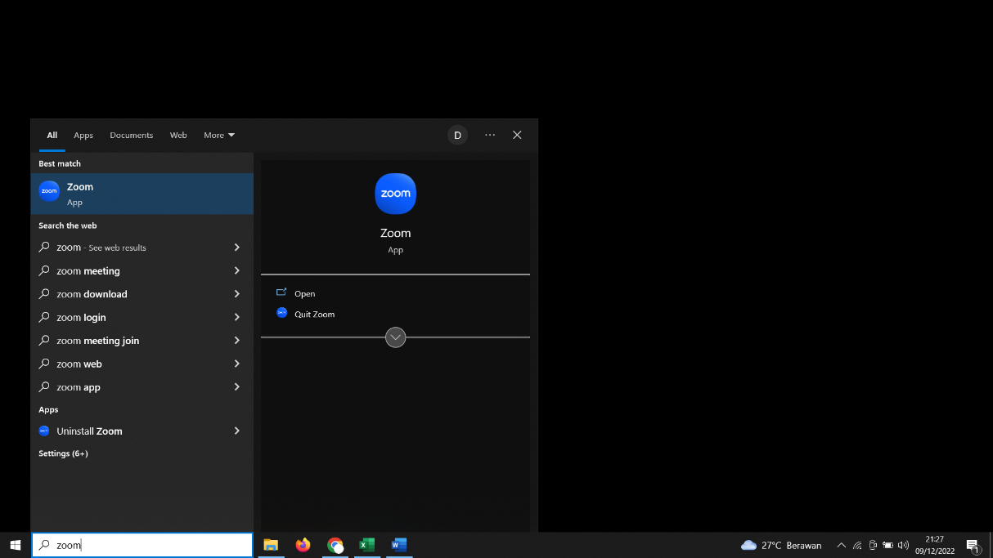
- Silahkan cari Nama anda dan Klik ”Start Meeting”
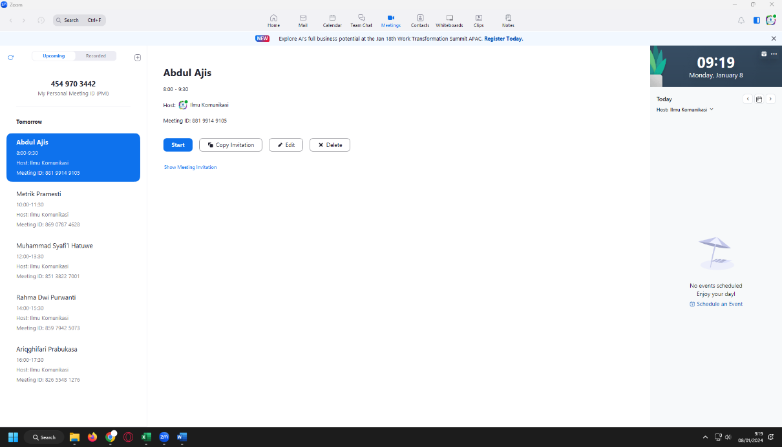

- Link Sidang untuk dikirimkan ke dosen pembimbing anda di bawah ini (link terlampir)
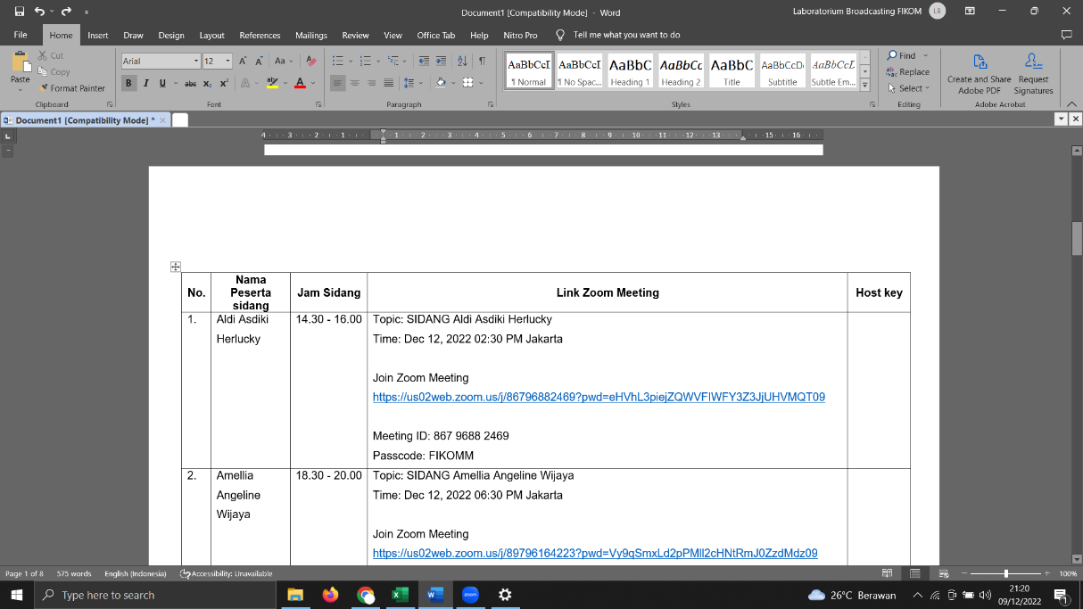

- Materi di upload di link :
https://drive.google.com/drive/folders/10RTBJzDaIjOpFzylhb4RMWeEWv_c-XLD?usp=sharing
(akses bisa CTRL+Klik link di atas)

LINK ZOOM SIDANG PERIODE JULI 2026 ( SELASA, 14 JULI 2026)
No. | Nama Peserta Sidang | Jam Sidang | Link Zoom Meeting | Host Key
 | Rakhman Adhi Noor Bawono | 08.00 - 09.30 WIB | Topik: Rakhman Adhi Noor Bawono  Waktu: 14 Jul 2026 08:00 Jakarta  Bergabung ke Rapat Zoom  https://mercubuana-yogya-ac-id.zoom.us/j/98976608285?pwd=vl78lkHvxQRsDDcqM9TlLhZfTESAGa.1  ID Rapat: 989 7660 8285  Kode Sandi: FIKOMM | Host Key: 012023
 | Fadila A. Ontoh | 08.00 - 09.30 WIB | Topic: Fadila A. Ontoh  Time: Jul 14, 2026 08.00 Jakarta  Join Zoom Meeting  https://us05web.zoom.us/j/87938487450?pwd=1hhQNXHHjJx4CtjwupIlJ4qYIqAYNb.1  Meeting ID: 879 3848 7450  Passcode: FIKOMM | Host Key: 242424
 | Mohammad Fathih Dhiaulhaq | 10.00 - 11.30 WIB | Topik: Mohammad Fathih Dhiaulhaq  Waktu: 14 Jul 2026 10:00 Jakarta  Bergabung ke Rapat Zoom  https://mercubuana-yogya-ac-id.zoom.us/j/98059541832?pwd=33Jk4rAUmAY9abuwEFs5jDKeoHxoPM.1  ID Rapat: 980 5954 1832  Kode Sandi: FIKOMM | Host Key: 012023
 | Hepy Prasillia | 10.00 - 11.30 WIB | Topic: Hepy Prasillia  Time: Jul 14, 2026 10.00 Jakarta  Join Zoom Meeting  https://us05web.zoom.us/j/87938487450?pwd=1hhQNXHHjJx4CtjwupIlJ4qYIqAYNb.1  Meeting ID: 879 3848 7450  Passcode: FIKOMM | Host Key: 242424
 | Yahya Marzuqi | 12.00 - 13.30 WIB | Topik: Yahya Marzuqi  Waktu: 14 Jul 2026 12:00 Jakarta  Bergabung ke Rapat Zoom  https://mercubuana-yogya-ac-id.zoom.us/j/96603283818?pwd=H5WYkrYhNQCWIhKPKcTKbBLo2vgwzz.1  ID Rapat: 966 0328 3818  Kode Sandi: FIKOMM | Host Key: 012023
 | Dhea Annisa | 12.00 - 13.30 WIB | Topic: Dhea Annisa  Time: Jul 14, 2026 12.00 Jakarta  Join Zoom Meeting  https://us05web.zoom.us/j/87938487450?pwd=1hhQNXHHjJx4CtjwupIlJ4qYIqAYNb.1  Meeting ID: 879 3848 7450  Passcode: FIKOMM | Host Key: 242424
 | Agnes Chintya Fanesa Sedo Mamun | 14.00 - 15.30 WIB | Topik: Agnes Chintya Fanesa Sedo Mamun  Waktu: 14 Jul 2026 14:00 Jakarta  Bergabung ke Rapat Zoom  https://mercubuana-yogya-ac-id.zoom.us/j/93821968338?pwd=InNFAWLF9yuX6fdEK0farOVdDYbcpM.1  ID Rapat: 938 2196 8338  Kode Sandi: FIKOMM | Host Key: 012023
 | Fatikha Maharani Nugroho | 14.00 - 15.30 WIB | Topic: Fatikha Maharani Nugroho  Time: Jul 14, 2026 14.00 Jakarta  Join Zoom Meeting  https://us05web.zoom.us/j/87938487450?pwd=1hhQNXHHjJx4CtjwupIlJ4qYIqAYNb.1  Meeting ID: 879 3848 7450  Passcode: FIKOMM | Host Key: 242424
 | Dwi Maharani | 16.00 - 17.30 WIB | Topik: Dwi Maharani  Waktu: 14 Jul 2026 16:00 Jakarta  Bergabung ke Rapat Zoom  https://mercubuana-yogya-ac-id.zoom.us/j/91815616143?pwd=ldaypDzdvzw0qDar0hHCG78gZFY5Nz.1  ID Rapat: 918 1561 6143  Kode Sandi: FIKOMM | Host Key: 012023
 | Fitria Happy Perdana | 16.00 - 17.30 WIB | Topic: Fitria Happy Perdana  Time: Jul 14, 2026 16.00 Jakarta  Join Zoom Meeting  https://us05web.zoom.us/j/87938487450?pwd=1hhQNXHHjJx4CtjwupIlJ4qYIqAYNb.1  Meeting ID: 879 3848 7450  Passcode: FIKOMM | Host Key: 242424

LINK ZOOM SIDANG PERIODE JULI 2026 (RABU, 15 JULI 2026)
No. | Nama Peserta Sidang | Jam Sidang | Link Zoom Meeting | Host Key
 | Yohanes Sucipto | 13.00 - 14.30 WIB | Topik: Yohanes Sucipto  Waktu: 15 Jul 2026 13:00 Jakarta  Bergabung ke Rapat Zoom  https://mercubuana-yogya-ac-id.zoom.us/j/92239000602?pwd=PI7KTqYbk0fgoFkbP1ABqI2F0IaCSU.1  ID Rapat: 922 3900 0602  Kode Sandi: FIKOMM | Host Key: 012023
 | Shalisa Isfandiari Dewi | 13.00 - 14.30 WIB | Topic: Shalisa Isfandiari Dewi  Time: Jul 15, 2026 13.00 Jakarta  Join Zoom Meeting  https://us05web.zoom.us/j/87938487450?pwd=1hhQNXHHjJx4CtjwupIlJ4qYIqAYNb.1  Meeting ID: 879 3848 7450  Passcode: FIKOMM | Host Key: 242424
 | Eci Fatmala | 15.00 - 16.30 WIB | Topik: Eci Fatmala  Waktu: 15 Jul 2026 15:00 Jakarta  Bergabung ke Rapat Zoom  https://mercubuana-yogya-ac-id.zoom.us/j/97952982273?pwd=e4Af67hKigVagLy7Z6TFiatu6CBVPU.1  ID Rapat: 979 5298 2273  Kode Sandi: FIKOMM | Host Key: 012023
 | Erlian Ruth Geovani Sianipar | 15.00 - 16.30 WIB | Topic: Erlian Ruth Geovani Sianipar  Time: Jul 15, 2026 15.00 Jakarta  Join Zoom Meeting  https://us05web.zoom.us/j/87938487450?pwd=1hhQNXHHjJx4CtjwupIlJ4qYIqAYNb.1  Meeting ID: 879 3848 7450  Passcode: FIKOMM | Host Key: 242424

LINK ZOOM SIDANG PERIODE JULI 2026 (KAMIS, 16 JULI 2026)
No. | Nama Peserta Sidang | Jam Sidang | Link Zoom Meeting | Host Key
 | Evi Fani Tanta Ginting | 08.00 - 09.30 WIB | Topik: Evi Fani Tanta Ginting  Waktu: 16 Jul 2026 08:00 Jakarta  Bergabung ke Rapat Zoom  https://mercubuana-yogya-ac-id.zoom.us/j/98118688426?pwd=sBH2bnaXhvYgT0clw5AsEybYNpzQRo.1  ID Rapat: 981 1868 8426  Kode Sandi: FIKOMM | Host Key: 012023
 | Rini Rahyuni | 08.00 - 09.30 WIB | Topic: Rini Rahyuni  Time: Jul 16, 2026 08.00 Jakarta  Join Zoom Meeting  https://us05web.zoom.us/j/87938487450?pwd=1hhQNXHHjJx4CtjwupIlJ4qYIqAYNb.1  Meeting ID: 879 3848 7450  Passcode: FIKOMM | Host Key: 242424
 | Katarina Tiratang | 10.00 - 11.30 WIB | Topik: Katarina Tiratang  Waktu: 16 Jul 2026 10:00 Jakarta  Bergabung ke Rapat Zoom  https://mercubuana-yogya-ac-id.zoom.us/j/95820080510?pwd=AgOjSA1EjNpzDWJVtOiOp5aXrJABJA.1  ID Rapat: 958 2008 0510  Kode Sandi: FIKOMM | Host Key: 012023
 | Fisti Eirene Sabatini | 10.00 - 11.30 WIB | Topic: Fisti Eirene Sabatini  Time: Jul 16, 2026 10.00 Jakarta  Join Zoom Meeting  https://us05web.zoom.us/j/87938487450?pwd=1hhQNXHHjJx4CtjwupIlJ4qYIqAYNb.1  Meeting ID: 879 3848 7450  Passcode: FIKOMM | Host Key: 242424
 | Yuni Pratama S | 12.00 - 13.30 WIB | Topik: Yuni Pratama S  Waktu: 16 Jul 2026 12:00 Jakarta  Bergabung ke Rapat Zoom  https://mercubuana-yogya-ac-id.zoom.us/j/95182851478?pwd=1TlaRe50Vbsgm6THE8y6bpBnxFFcbM.1  ID Rapat: 951 8285 1478  Kode Sandi: FIKOMM | Host Key: 012023
 | Mychael Ronaldo Jeremia | 12.00 - 13.30 WIB | Topic: Mychael Ronaldo Jeremia  Time: Jul 16, 2026 12:00 Jakarta  Join Zoom Meeting  https://us05web.zoom.us/j/87938487450?pwd=1hhQNXHHjJx4CtjwupIlJ4qYIqAYNb.1  Meeting ID: 879 3848 7450  Passcode: FIKOMM | Host Key: 242424
 | Glorya Miranda Palito | 14.00 - 15.30 WIB | Topik: Glorya Miranda Palito  Waktu: 16 Jul 2026 14:00 Jakarta  Bergabung ke Rapat Zoom  https://mercubuana-yogya-ac-id.zoom.us/j/99778755496?pwd=zuYCciCIFp4IOekO8qw5HV4hvWhCnl.1  ID Rapat: 997 7875 5496  Kode Sandi: FIKOMM | Host Key: 012023
 | Clarinsa Hanin Hermawan | 14.00 - 15.30 WIB | Topic: Clarinsa Hanin Hermawan  Time: Jul 16, 2026 14.00 Jakarta  Join Zoom Meeting  https://us05web.zoom.us/j/87938487450?pwd=1hhQNXHHjJx4CtjwupIlJ4qYIqAYNb.1  Meeting ID: 879 3848 7450  Passcode: FIKOMM | Host Key: 242424
 | Eva Dwi Yanti | 16.00 - 17.30 WIB | Topik: Eva Dwi Yanti  Waktu: 16 Jul 2026 16:00 Jakarta  Bergabung ke Rapat Zoom  https://mercubuana-yogya-ac-id.zoom.us/j/96666550863?pwd=UJzrL0gM4kHnwRQiNvourDpVo6P0lO.1  ID Rapat: 966 6655 0863  Kode Sandi: FIKOMM | Host Key: 012023
 | Naflah Nabila Tunisha | 16.00 - 17.30 WIB | Topic: Naflah Nabila Tunisha  Time: Jul 16, 2026 16.00 Jakarta  Join Zoom Meeting  https://us05web.zoom.us/j/87938487450?pwd=1hhQNXHHjJx4CtjwupIlJ4qYIqAYNb.1  Meeting ID: 879 3848 7450  Passcode: FIKOMM | Host Key: 242424

LINK ZOOM SIDANG PERIODE JULI 2026 (JUMAT, 17 JULI 2026)
No. | Nama Peserta Sidang | Jam Sidang | Link Zoom Meeting | Host Key
 | Rethni Jelita Br Tarigan | 08.00 - 09.30 WIB | Topik: Rethni Jelita Br Tarigan  Waktu: 17 Jul 2026 08:00 Jakarta  Bergabung ke Rapat Zoom  https://mercubuana-yogya-ac-id.zoom.us/j/96726992081?pwd=vnIFLmGTIZziBXxmmO5lO9LzXVzwpE.1  ID Rapat: 967 2699 2081  Kode Sandi: FIKOMM | Host Key: 012023
 | Muhammad Revaldo | 08.00 - 09.30 WIB | Topic: Muhammad Revaldo  Time: Jul 17, 2026 08.00 Jakarta  Join Zoom Meeting  https://us05web.zoom.us/j/87938487450?pwd=1hhQNXHHjJx4CtjwupIlJ4qYIqAYNb.1  Meeting ID: 879 3848 7450  Passcode: FIKOMM | Host Key: 242424
 | Muhammad Rizky Ardi Saputra | 10.00 - 11.30 WIB | Topik: Muhammad Rizky Ardi Saputra  Waktu: 17 Jul 2026 10:00 Jakarta  Bergabung ke Rapat Zoom  https://mercubuana-yogya-ac-id.zoom.us/j/97932646771?pwd=KNnoOQgzTbHpsLQi4GWJPAen2U7aII.1  ID Rapat: 979 3264 6771  Kode Sandi: FIKOMM | Host Key: 012023
 | Senik Rahayu | 10.00 - 11.30 WIB | Topic: Senik Rahayu  Time: Jul 17, 2026 10.00 Jakarta  Join Zoom Meeting  https://us05web.zoom.us/j/87938487450?pwd=1hhQNXHHjJx4CtjwupIlJ4qYIqAYNb.1  Meeting ID: 879 3848 7450  Passcode: FIKOMM | Host Key: 242424
 | Afrizal Azwan Dinzar | 13.00 - 14.30 WIB | Topik: Afrizal Azwan Dinzar  Waktu: 17 Jul 2026 13:00 Jakarta  Bergabung ke Rapat Zoom  https://mercubuana-yogya-ac-id.zoom.us/j/96552646505?pwd=5AGbeadnW2OASL2M2IiLfsbobg6t1X.1  ID Rapat: 965 5264 6505  Kode Sandi: FIKOMM | Host Key: 012023
 | Jihan Rahma Hidayah | 13.00 - 14.30 WIB | Topic: Jihan Rahma Hidayah  Time: Jul 17, 2026 13.00 Jakarta  Join Zoom Meeting  https://us05web.zoom.us/j/87938487450?pwd=1hhQNXHHjJx4CtjwupIlJ4qYIqAYNb.1  Meeting ID: 879 3848 7450  Passcode: FIKOMM | Host Key: 242424
 | Dewi Ardyati Nurjanah | 15.00 - 16.30 WIB | Topik: Dewi Ardyati Nurjanah  Waktu: 17 Jul 2026 15:00 Jakarta  Bergabung ke Rapat Zoom  https://mercubuana-yogya-ac-id.zoom.us/j/99884657256?pwd=wFeaHpbdZOi60gKVMCXa5y4nadxsty.1  ID Rapat: 998 8465 7256  Kode Sandi: FIKOMM | Host Key: 012023
 | Annas Aghniya' Hakim | 15.00 - 16.30 WIB | Topic: Annas Aghniya' Hakim  Time: Jul 17, 2026 15.00 Jakarta  Join Zoom Meeting  https://us05web.zoom.us/j/87938487450?pwd=1hhQNXHHjJx4CtjwupIlJ4qYIqAYNb.1  Meeting ID: 879 3848 7450  Passcode: FIKOMM | Host Key: 242424

LINK ZOOM SIDANG PERIODE JULI 2026 (SENIN, 20 JULI 2026)
No. | Nama Peserta Sidang | Jam Sidang | Link Zoom Meeting | Host Key
 | Annisa Farida Hasibuan | 08.00 - 09.30 WIB | Topik: Annisa Farida Hasibuan  Waktu: 20 Jul 2026 08:00 Jakarta  Bergabung ke Rapat Zoom  https://mercubuana-yogya-ac-id.zoom.us/j/93938638643?pwd=jzni1vFPdEyJNVjfS9HkBhav7SCvNJ.1  ID Rapat: 939 3863 8643  Kode Sandi: FIKOMM | Host Key: 012023
 | Aldo Christyanto | 08.00 - 09.30 WIB | Topic: Aldo Christyanto  Time: Jul 20, 2026 08.00 Jakarta  Join Zoom Meeting  https://us05web.zoom.us/j/87938487450?pwd=1hhQNXHHjJx4CtjwupIlJ4qYIqAYNb.1  Meeting ID: 879 3848 7450  Passcode: FIKOMM | Host Key: 242424
 | Shefira Nabila | 10.00 - 11.30 WIB | Topik: Shefira Nabila  Waktu: 20 Jul 2026 10:00 Jakarta  Bergabung ke Rapat Zoom  https://mercubuana-yogya-ac-id.zoom.us/j/95251584434?pwd=sOjuGCFUUc15TaJcn65RuWbDlxyFaa.1  ID Rapat: 952 5158 4434  Kode Sandi: FIKOMM | Host Key: 012023
 | Miko Yuristiawan | 10.00 - 11.30 WIB | Topic: Miko Yuristiawan  Time: Jul 20, 2026 10.00 Jakarta  Join Zoom Meeting  https://us05web.zoom.us/j/87938487450?pwd=1hhQNXHHjJx4CtjwupIlJ4qYIqAYNb.1  Meeting ID: 879 3848 7450  Passcode: FIKOMM | Host Key: 242424
 | Zidan | 12.00 - 13.30 WIB | Topik: Zidan  Waktu: 20 Jul 2026 12:00 Jakarta  Bergabung ke Rapat Zoom  https://mercubuana-yogya-ac-id.zoom.us/j/92311276738?pwd=j3mbIf2bZl2ltOufutFVhVfgpbFJPZ.1  ID Rapat: 923 1127 6738  Kode Sandi: FIKOMM | Host Key: 012023
 | Margareth Bebi Pujangga Sabebegen | 12.00 - 13.30 WIB | Topic: Margareth Bebi Pujangga Sabebegen  Time: Jul 20, 2026 12.00 Jakarta  Join Zoom Meeting  https://us05web.zoom.us/j/87938487450?pwd=1hhQNXHHjJx4CtjwupIlJ4qYIqAYNb.1  Meeting ID: 879 3848 7450  Passcode: FIKOMM | Host Key: 242424
 | Viorella Christina Usmany | 14.00 - 15.30 WIB | Topik: Viorella Christina Usmany  Waktu: 20 Jul 2026 14:00 Jakarta  Bergabung ke Rapat Zoom  https://mercubuana-yogya-ac-id.zoom.us/j/91878662370?pwd=F2WHoAUQYNtEZKEx3T9zcjVe2YdbWE.1  ID Rapat: 918 7866 2370  Kode Sandi: FIKOMM | Host Key: 012023
 | Rundesi | 14.00 - 15.30 WIB | Topic: Rundesi  Time: Jul 20, 2026 14.00 Jakarta  Join Zoom Meeting  https://us05web.zoom.us/j/87938487450?pwd=1hhQNXHHjJx4CtjwupIlJ4qYIqAYNb.1  Meeting ID: 879 3848 7450  Passcode: FIKOMM | Host Key: 242424
 | Intan Tri Nur Aini | 16.00 - 17.30 WIB | Topik: Intan Tri Nur Aini  Waktu: 20 Jul 2026 16:00 Jakarta  Bergabung ke Rapat Zoom  https://mercubuana-yogya-ac-id.zoom.us/j/92169861336?pwd=HDX0alYFb03Wz1w15CAshwm1Jlp1QD.1  ID Rapat: 921 6986 1336  Kode Sandi: FIKOMM | Host Key: 012023
 | Indri Agata | 16.00 - 17.30 WIB | Topic: Indri Agata  Time: Jul 20, 2026 16.00 Jakarta  Join Zoom Meeting  https://us05web.zoom.us/j/87938487450?pwd=1hhQNXHHjJx4CtjwupIlJ4qYIqAYNb.1  Meeting ID: 879 3848 7450  Passcode: FIKOMM | Host Key: 242424

LINK ZOOM SIDANG PERIODE JULI 2026 (SELASA, 21 JULI 2026)
No. | Nama Peserta Sidang | Jam Sidang | Link Zoom Meeting | Host Key
 | Alice Irene Butar-Butar | 08.00 - 09.30 WIB | Topik: Alice Irene Butar-Butar  Waktu: 21 Jul 2026 08:00 Jakarta  Bergabung ke Rapat Zoom  https://mercubuana-yogya-ac-id.zoom.us/j/94695138096?pwd=bknad8YVveD4XOGQj6Bl7HGCGeKMbv.1  ID Rapat: 946 9513 8096  Kode Sandi: FIKOMM | Host Key: 012023
 | Chintya Putri Hartati | 08.00 - 09.30 WIB | Topic: Chintya Putri Hartati  Time: Jul 21, 2026 08.00 Jakarta  Join Zoom Meeting  https://us05web.zoom.us/j/87938487450?pwd=1hhQNXHHjJx4CtjwupIlJ4qYIqAYNb.1  Meeting ID: 879 3848 7450  Passcode: FIKOMM | Host Key: 242424
 | Sarina Rulita | 10.00 - 11.30 WIB | Topik: Sarina Rulita  Waktu: 21 Jul 2026 10:00 Jakarta  Bergabung ke Rapat Zoom  https://mercubuana-yogya-ac-id.zoom.us/j/98320376199?pwd=Qr78kX5I3o7GRwngEwnvaFdqUnKgTE.1  ID Rapat: 983 2037 6199  Kode Sandi: FIKOMM | Host Key: 012023
 | Meitha Tri Herliyana | 10.00 - 11.30 WIB | Topic: Meitha Tri Herliyana  Time: Jul 21, 2026 10.00 Jakarta  Join Zoom Meeting  https://us05web.zoom.us/j/87938487450?pwd=1hhQNXHHjJx4CtjwupIlJ4qYIqAYNb.1  Meeting ID: 879 3848 7450  Passcode: FIKOMM | Host Key: 242424
 | Agatha Yesia Rustania | 12.00 - 13.30 WIB | Topik: Agatha Yesia Rustania  Waktu: 21 Jul 2026 12:00 Jakarta  Bergabung ke Rapat Zoom  https://mercubuana-yogya-ac-id.zoom.us/j/94111699928?pwd=gE3ORmUpxHS79LLL9vIe7q5YYLyilR.1  ID Rapat: 941 1169 9928  Kode Sandi: FIKOMM | Host Key: 012023
 | Tri Puji Astuti | 14.00 - 15.30 WIB | Topik: Tri Puji Astuti  Waktu: 21 Jul 2026 14:00 Jakarta  Bergabung ke Rapat Zoom  https://mercubuana-yogya-ac-id.zoom.us/j/92124289262?pwd=QbQHatFaJ9gUqMBAyfxWr3miockn9r.1  ID Rapat: 921 2428 9262  Kode Sandi: FIKOMM | Host Key: 012023
 | Muhamad Ibnu Fahrizal Yunus | 16.00 - 17.30 WIB | Topik: Muhamad Ibnu Fahrizal Yunus  Waktu: 21 Jul 2026 16:00 Jakarta  Bergabung ke Rapat Zoom  https://mercubuana-yogya-ac-id.zoom.us/j/97184622332?pwd=Pt5ntceBOiS7uNd0pT4NdCoW0dPEhu.1  ID Rapat: 971 8462 2332  Kode Sandi: FIKOMM | Host Key: 012023
 | Tereza Febrian Loveleen | 16.00 - 17.30 WIB | Topic: Tereza Febrian Loveleen  Time: Jul 21, 2026 16.00 Jakarta  Join Zoom Meeting  https://us05web.zoom.us/j/87938487450?pwd=1hhQNXHHjJx4CtjwupIlJ4qYIqAYNb.1  Meeting ID: 879 3848 7450  Passcode: FIKOMM | Host Key: 242424

LINK ZOOM SIDANG PERIODE JULI 2026 (JUMAT, 24 JULI 2026)
No. | Nama Peserta Sidang | Jam Sidang | Link Zoom Meeting | Host Key
 | Ridwan Nur Andryyanto | 08.00 - 09.30 WIB | Topik: Ridwan Nur Andryyanto  Waktu: 24 Jul 2026 08:00 Jakarta  Bergabung ke Rapat Zoom  https://mercubuana-yogya-ac-id.zoom.us/j/99296656227?pwd=jAtUaBeoyJtMzkMbfc7ctoIfDTsz7a.1  ID Rapat: 992 9665 6227  Kode Sandi: FIKOMM | Host Key: 012023
 | Fauzi Triananda Alwi | 08.00 - 09.30 WIB | Topic: Fauzi Triananda Alwi  Time: Jul 24, 2026 08.00 Jakarta  Join Zoom Meeting  https://us05web.zoom.us/j/87938487450?pwd=1hhQNXHHjJx4CtjwupIlJ4qYIqAYNb.1  Meeting ID: 879 3848 7450  Passcode: FIKOMM | Host Key: 242424
 | David Berliansyah | 10.00 - 11.30 WIB | Topik: David Berliansyah  Waktu: 24 Jul 2026 10:00 Jakarta  Bergabung ke Rapat Zoom  https://mercubuana-yogya-ac-id.zoom.us/j/91715947010?pwd=0q8bbex9ed6vmFsTKYMx6MnVsbJEEY.1  ID Rapat: 917 1594 7010  Kode Sandi: FIKOMM | Host Key: 012023
 | Julius Brian Yahui | 10.00 - 11.30 WIB | Topic: Julius Brian Yahui  Time: Jul 24, 2026 10.00 Jakarta  Join Zoom Meeting  https://us05web.zoom.us/j/87938487450?pwd=1hhQNXHHjJx4CtjwupIlJ4qYIqAYNb.1  Meeting ID: 879 3848 7450  Passcode: FIKOMM | Host Key: 242424
 | Anura Riskiana | 13.00 - 14.30 | Topik: Anura Riskiana  Waktu: 24 Jul 2026 13:00 Jakarta  Bergabung ke Rapat Zoom  https://mercubuana-yogya-ac-id.zoom.us/j/91305296079?pwd=JXcTWZOYkdhpEsHCFSTbweZpopc2k3.1  ID Rapat: 913 0529 6079  Kode Sandi: FIKOMM | Host Key: 012023
 | Moch Dharmawan Praditya Simatupang | 13.00 - 14.30 | Topic: Moch Dharmawan Praditya Simatupang  Time: Jul 24, 2026 13.00 Jakarta  Join Zoom Meeting  https://us05web.zoom.us/j/87938487450?pwd=1hhQNXHHjJx4CtjwupIlJ4qYIqAYNb.1  Meeting ID: 879 3848 7450  Passcode: FIKOMM | Host Key: 242424

