SOP & LINK ZOOM PESERTA SIDANG FIKOMM
UNIVERSITAS MERCU BUANA YOGYAKARTA

LANGKAH MENGGUNAKAN LINK ZOOM FAKULTAS UMBY:
- Buka aplikasi zoom meeting di laptop yang disediakan laboratorium FIKOMM :
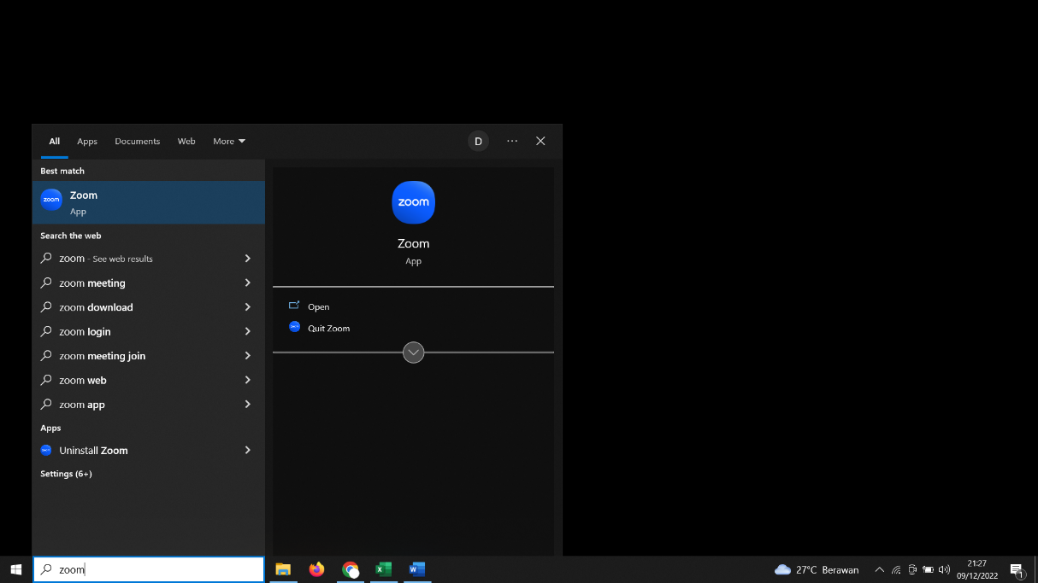
- Silahkan cari Nama anda dan Klik ”Start Meeting”
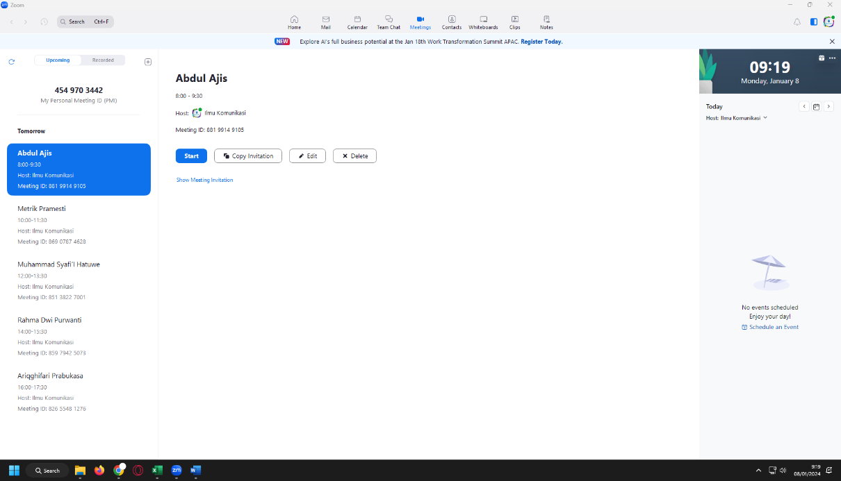

- Link Sidang untuk dikirimkan ke dosen pembimbing anda di bawah ini (link terlampir)
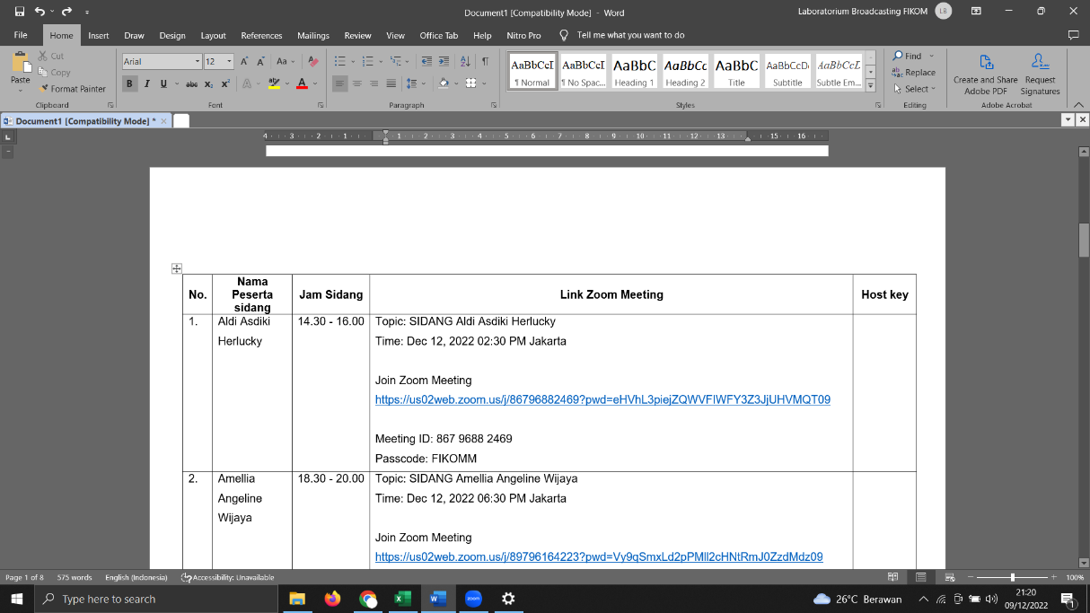

- Materi di upload di link :
https://drive.google.com/drive/folders/10RTBJzDaIjOpFzylhb4RMWeEWv_c-XLD?usp=sharing
(akses bisa CTRL+Klik link di atas)

LINK ZOOM SIDANG PERIODE NOVEMBER 2025 (Rabu, 12 November 2025)

No. | Nama Peserta Sidang | Jam Sidang | Link Zoom Meeting | Host Key
 | SYAFIRA NORHALIZA | 08.00 - 09.30 WIB | Topik: SYAFIRA NORHALIZA  Waktu: 12 Nov 2025 08:00 Jakarta  Bergabung ke Rapat Zoom  https://us02web.zoom.us/j/82934583014?pwd=Ke5rgGNuTMB63FlsBe19eQUgMSamWK.1  ID Rapat: 829 3458 3014  Kode Sandi: FIKOMM | Host Key: 012023
 | ELVA LAILATUN NABILA | 08.00 - 09.30 WIB | Topic: ELVA LAILATUN NABILA  Time: Nov 12, 2025 08.00 - 09.30 WIB  Join Zoom Meeting  https://us06web.zoom.us/j/82956325961?pwd=6ndV9bHowQaZG3C5UahUnZ2UFN1JNx.1  Meeting ID: 829 5632 5961  Passcode: FIKOMM | HOSTKEY : 111888
 | KADEK SUKMA CAHYANI WISNAWA | 10.00 - 11.30 WIB | Topik: KADEK SUKMA CAHYANI WISNAWA  Waktu: 12 Nov 2025 10:00 Jakarta  Bergabung ke Rapat Zoom  https://us02web.zoom.us/j/82161824521?pwd=gYVwekAQaHuqFbuwQPiqYfMmHgZVKi.1  ID Rapat: 821 6182 4521  Kode Sandi: FIKOMM | Host Key: 012023
 | FAJAR PURUHITA | 10.00 - 11.30 WIB | Topic: FAJAR PURUHITA  Time: Nov 12, 2025 10.00 - 11.30 WIB  Join Zoom Meeting  https://us06web.zoom.us/j/82956325961?pwd=6ndV9bHowQaZG3C5UahUnZ2UFN1JNx.1  Meeting ID: 829 5632 5961  Passcode: FIKOMM | HOSTKEY : 111888
 | MUHAMMAD ARIF FUADI | 12.30 - 14.00 WIB | Topik: MUHAMMAD ARIF FUADI  Waktu: 12 Nov 2025 12:30 Jakarta  Bergabung ke Rapat Zoom  https://us02web.zoom.us/j/85964225057?pwd=xmBHvTEngoWWUTa25bQl8LjyAOXRca.1  ID Rapat: 859 6422 5057  Kode Sandi: FIKOMM | Host Key: 012023
 | YOLANDA SAULINA BUTAR-BUTAR | 14.30 - 16.00 WIB | Topik: YOLANDA SAULINA BUTAR-BUTAR  Waktu: 12 Nov 2025 14:30 Jakarta  Bergabung ke Rapat Zoom  https://us02web.zoom.us/j/84903737749?pwd=4jNsE7bGBnFw1fp4aJVkOtOqS4uNTV.1  ID Rapat: 849 0373 7749  Kode Sandi: FIKOMM | Host Key: 012023
 | RAHMI SATYAWATI | 14.30 - 16.00 WIB | Topic: RAHMI SATYAWATI  Time: Nov 12, 2025 14.30 - 16.00 WIB  Join Zoom Meeting  https://us06web.zoom.us/j/82956325961?pwd=6ndV9bHowQaZG3C5UahUnZ2UFN1JNx.1  Meeting ID: 829 5632 5961  Passcode: FIKOMM | HOSTKEY : 111888
 | LILI ADINDA | 16.30 - 18.00 WIB | Topik: LILI ADINDA  Waktu: 12 Nov 2025 16:30 Jakarta  Bergabung ke Rapat Zoom  https://us02web.zoom.us/j/89296286746?pwd=1MW6CWy81n6xt3qWKAa5NFgFozG5CE.1  ID Rapat: 892 9628 6746  Kode Sandi: FIKOMM | Host Key: 012023
 | SHERLY DEVITA | 16.30 - 18.00 WIB | Topic: SHERLY DEVITA  Time: Nov 12, 2025 16.30 - 18.00 WIB  Join Zoom Meeting  https://us06web.zoom.us/j/82956325961?pwd=6ndV9bHowQaZG3C5UahUnZ2UFN1JNx.1  Meeting ID: 829 5632 5961  Passcode: FIKOMM | HOSTKEY : 111888
 | WINDRA ARDHANU | 18.30 - 20.00 WIB | Topik: WINDRA ARDHANU  Waktu: 12 Nov 2025 18:30 Jakarta  Bergabung ke Rapat Zoom  https://us02web.zoom.us/j/84748372115?pwd=ZUJhISBaqFSGIL0RQSdZHyGqDPyz3v.1  ID Rapat: 847 4837 2115  Kode Sandi: FIKOMM | Host Key: 012023
 | RIVALDO IMANUEL SAPUTRA | 18.30 - 20.00 WIB | Topic: RIVALDO IMANUEL SAPUTRA  Time: Nov 12, 2025 18.30 - 20.00 WIB  Join Zoom Meeting  https://us06web.zoom.us/j/82956325961?pwd=6ndV9bHowQaZG3C5UahUnZ2UFN1JNx.1  Meeting ID: 829 5632 5961  Passcode: FIKOMM | HOSTKEY : 111888

LINK ZOOM SIDANG PERIODE NOVEMBER 2025 (KAMIS, 13 November 2025)

No. | Nama Peserta Sidang | Jam Sidang | Link Zoom Meeting | Host Key
 | HAFID ILHAM PRATAMA | 08.00 - 09.30 WIB | Topik: HAFID ILHAM PRATAMA  Waktu: 13 Nov 2025 08:00 Jakarta  Bergabung ke Rapat Zoom  https://us02web.zoom.us/j/81118960889?pwd=f4RSzsssrftlLRtgui2Vq1JqOzCRlb.1  ID Rapat: 811 1896 0889  Kode Sandi: FIKOMM | Host Key: 012023
 | FAIQ RIVALDY | 08.00 - 09.30 WIB | Topic: FAIQ RIVALDY  Time: Nov 13, 2025 08.00 - 09.30 WIB  Join Zoom Meeting  https://us06web.zoom.us/j/89745377317?pwd=7IaketIIKZCvkFdVNco0wpjMRFbaCh.1  Meeting ID: 897 4537 7317  Passcode: FIKOMM | HOSTKEY : 111888
 | TALISSA RASENDRIYA | 10.00 - 11.30 WIB | Topik: TALISSA RASENDRIYA  Waktu: 13 Nov 2025 10:00 Jakarta  Bergabung ke Rapat Zoom  https://us02web.zoom.us/j/81243688922?pwd=NaxbkGRo2vQaJ2mrvZ5eDcXTyXeDoh.1  ID Rapat: 812 4368 8922  Kode Sandi: FIKOMM | Host Key: 012023
 | AZHFAR FARZA MAHENDRA | 10.00 - 11.30 WIB | Topic: AZHFAR FARZA MAHENDRA  Time: Nov 13, 2025 10.00 - 11.30 WIB  Join Zoom Meeting  https://us06web.zoom.us/j/89745377317?pwd=7IaketIIKZCvkFdVNco0wpjMRFbaCh.1  Meeting ID: 897 4537 7317  Passcode: FIKOMM | HOSTKEY : 111888
 | FRANSISKA LISSA | 12.30 - 14.00 WIB | Topik: FRANSISKA LISSA  Waktu: 13 Nov 2025 12:30 Jakarta  Bergabung ke Rapat Zoom  https://us02web.zoom.us/j/82635306691?pwd=WBbn4qpOXbYI87vrTWwNCb0PyX1aUh.1  ID Rapat: 826 3530 6691  Kode Sandi: FIKOMM | Host Key: 012023
 | MUHAMAD FAHRUL HIDAYAT | 12.30 - 14.00 WIB | Topic: MUHAMAD FAHRUL HIDAYAT  Time: Nov 13, 2025 12.30 - 14.00 WIB  Join Zoom Meeting  https://us06web.zoom.us/j/89745377317?pwd=7IaketIIKZCvkFdVNco0wpjMRFbaCh.1  Meeting ID: 897 4537 7317  Passcode: FIKOMM | HOSTKEY : 111888
 | ANICETUS AWUR | 14.30 - 16.00 WIB | Topik: ANICETUS AWUR  Waktu: 13 Nov 2025 14:30 Jakarta  Bergabung ke Rapat Zoom  https://us02web.zoom.us/j/81502621008?pwd=Ct3GSMjz0xTcsbsmllD3X02asAG8Ry.1  ID Rapat: 815 0262 1008  Kode Sandi: FIKOMM | Host Key: 012023
 | MUHAMMAD ILHAM RAMDHANI HAKIM | 14.30 - 16.00 WIB | Topic: MUHAMMAD ILHAM RAMDHANI HAKIM  Time: Nov 13, 2025 14.30 - 16.00 WIB  Join Zoom Meeting  https://us06web.zoom.us/j/89745377317?pwd=7IaketIIKZCvkFdVNco0wpjMRFbaCh.1  Meeting ID: 897 4537 7317  Passcode: FIKOMM | HOSTKEY : 111888
 | FRANSISKA MALA | 16.30 - 18.00 WIB | Topik: FRANSISKA MALA  Waktu: 13 Nov 2025 16:30 Jakarta  Bergabung ke Rapat Zoom  https://us02web.zoom.us/j/86910070822?pwd=JVVtOiQpPTF2i6xox3ccpr8vpTeAje.1  ID Rapat: 869 1007 0822  Kode Sandi: FIKOMM | Host Key: 012023
 | RAHMAD BAGASKARA | 16.30 - 18.00 WIB | Topic: RAHMAD BAGASKARA  Time: Nov 13, 2025 16.30 - 18.00 WIB  Join Zoom Meeting  https://us06web.zoom.us/j/89745377317?pwd=7IaketIIKZCvkFdVNco0wpjMRFbaCh.1  Meeting ID: 897 4537 7317  Passcode: FIKOMM | HOSTKEY : 111888
 | RIKI SAPUTRA | 18.30 - 20.00 WIB | Topik: RIKI SAPUTRA  Waktu: 13 Nov 2025 18:30 Jakarta  Bergabung ke Rapat Zoom  https://us02web.zoom.us/j/89836640290?pwd=QxFlaQxVRsLh9UrPnhg7OimgvYvAt6.1  ID Rapat: 898 3664 0290  Kode Sandi: FIKOMM | Host Key: 012023
 | ARIFIN SEFTIA NUGROHO | 18.30 - 20.00 WIB | Topic: ARIFIN SEFTIA NUGROHO  Time: Nov 13, 2025 18.30 - 20.00 WIB  Join Zoom Meeting  https://us06web.zoom.us/j/89745377317?pwd=7IaketIIKZCvkFdVNco0wpjMRFbaCh.1  Meeting ID: 897 4537 7317  Passcode: FIKOMM | HOSTKEY : 111888

LINK ZOOM SIDANG PERIODE NOVEMBER 2025 (JUMAT, 14 November 2025)

No. | Nama Peserta Sidang | Jam Sidang | Link Zoom Meeting | Host Key
 | NURWANTI ASLAM | 13.00 - 14.30 WIB | Topik: NURWANTI ASLAM  Waktu: 14 Nov 2025 13:00 Jakarta  Bergabung ke Rapat Zoom  https://us02web.zoom.us/j/83041731807?pwd=b6p84Wb3dNCikyITpzaGGzLeIJyu4F.1  ID Rapat: 830 4173 1807  Kode Sandi: FIKOMM | Host Key: 012023
 | ZAINAL ABIDIN SAPUTRA | 15.00 - 16.30 WIB | Topik: ZAINAL ABIDIN SAPUTRA  Waktu: 14 Nov 2025 15:00 Jakarta  Bergabung ke Rapat Zoom  https://us02web.zoom.us/j/84177897850?pwd=a4Yu6TWpTiqL0zqyj1aRrOCYfXZrDN.1  ID Rapat: 841 7789 7850  Kode Sandi: FIKOMM | Host Key: 012023
 | BENIGNA LESTARI DA CONCEICAO CARDOSO | 16.30 - 18.00 WIB | Topik: BENIGNA LESTARI DA CONCEICAO CARDOSO  Waktu: 14 Nov 2025 16:30 Jakarta  Bergabung ke Rapat Zoom  https://us02web.zoom.us/j/82165508660?pwd=icO96el2UEb3R1ItibOR44n7BkA1fb.1  ID Rapat: 821 6550 8660  Kode Sandi: FIKOMM | Host Key: 012023

